|  |
| --- |
| *CometPark* |
| **System Requirements Analysis** |
| **SE 6387 Advanced Software Engineering Project**  **R.Z. Wenkstern**    ***03/04/2014*** |

|  |
| --- |
| **Group *B 002*** |
| **Arunkumar Manickam** |
| **Hariprasad Natarajan** |
| **Prasanna Venkatesh Venkitasamy** |
| **Rekha Muthulakshmi Nachadalingam** |

# Revision History

|  |  |  |  |
| --- | --- | --- | --- |
| **Version** | **Date** | **Decription** | **Authors** |
| 1.0 | 02/27/2014 | Completed initial draft | Prasanna,Hari,Rekha,Arun |
| 2.0 | 03/04/2014 | Corrected the use case diagrams and added the fully dressed format for the use cases | Prasanna,Hari,Rekha,Arun |

Contents

[Revision History 2](#_Toc381533005)

[1. Domain Model 1](#_Toc381533006)

[2. System Use Case Diagrams 2](#_Toc381533007)

[2.1 Level 0 UCD 2](#_Toc381533008)

[2.2 Level 1 UCD 3](#_Toc381533009)

[3. Use Case Specification in Brief Format 4](#_Toc381533010)

[4. Use Case Prioritization 8](#_Toc381533011)

[5. Use Case Specification in Fully Dressed Format 9](#_Toc381533012)

[6. Black Box Sequence Diagrams 13](#_Toc381533013)

[UC 1.7 Update state of Parking Spot 13](#_Toc381533014)

[UC 1.1 Find Vacant Parking Spot 14](#_Toc381533015)

[UC 1.4 Login 15](#_Toc381533016)

[UC 1.5 Manage Parking Spots 16](#_Toc381533017)

[UC 1.6 Configure System 17](#_Toc381533018)

[4. Traceability Matrix 19](#_Toc381533019)

[Appendix A: Glossary 20](#_Toc381533020)

# List of Figures

[Figure 1 Domain Model of the CometPark System 2](#_Toc381533276)

[Figure 2 Level 0 Use Case Diagram 3](#_Toc381533277)

[Figure 3 Level 1 Use Case Diagram 4](#_Toc381533278)

[Figure 4 Update State of Parking Spot BB-SD 14](#_Toc381533279)

[Figure 5 Find Vacant Parking Spot BB-SD 15](#_Toc381533280)

[Figure 6 Login BB-SD 16](#_Toc381533281)

[Figure 7 Manage Parking Spots BB-SD 17](#_Toc381533282)

[Figure 8 Configure System BB-SD 18](#_Toc381533283)

[Figure 9 Traceability Matrix 19](#_Toc381533284)

# 1. Domain Model

The following diagram shows the Domain model of the CometPark system.

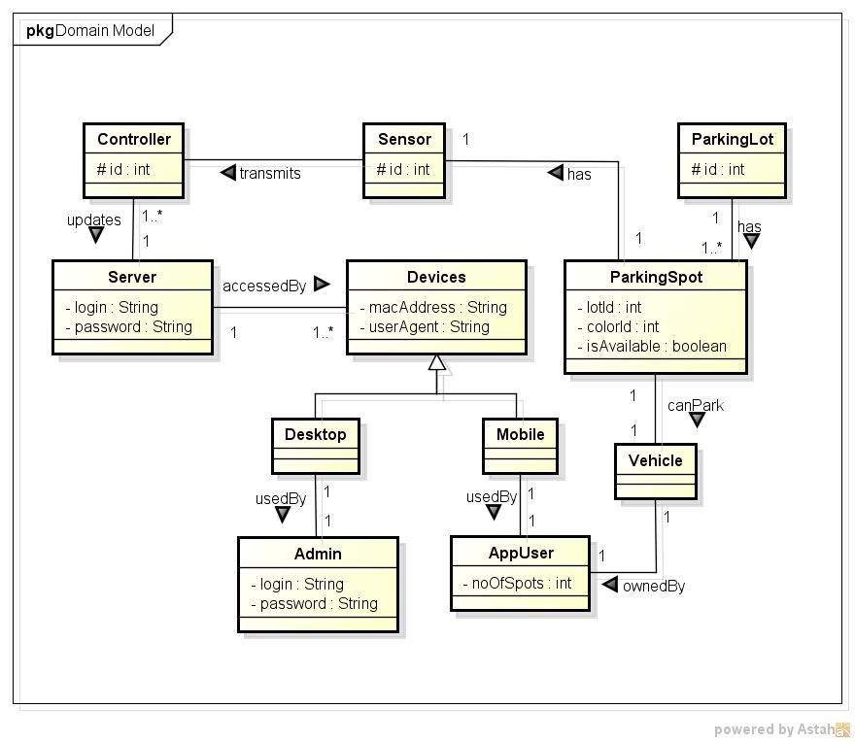

Figure 1 Domain Model of the CometPark System

# 2. System Use Case Diagrams

## 2.1 Level 0 UCD

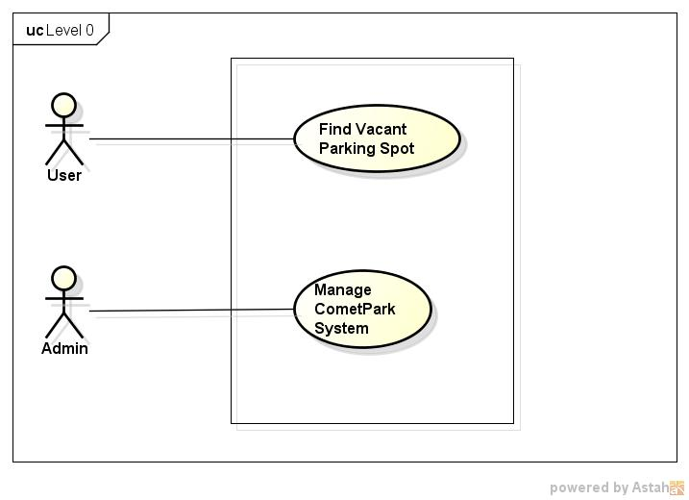

Figure 2 Level 0 Use Case Diagram

## 2.2 Level 1 UCD

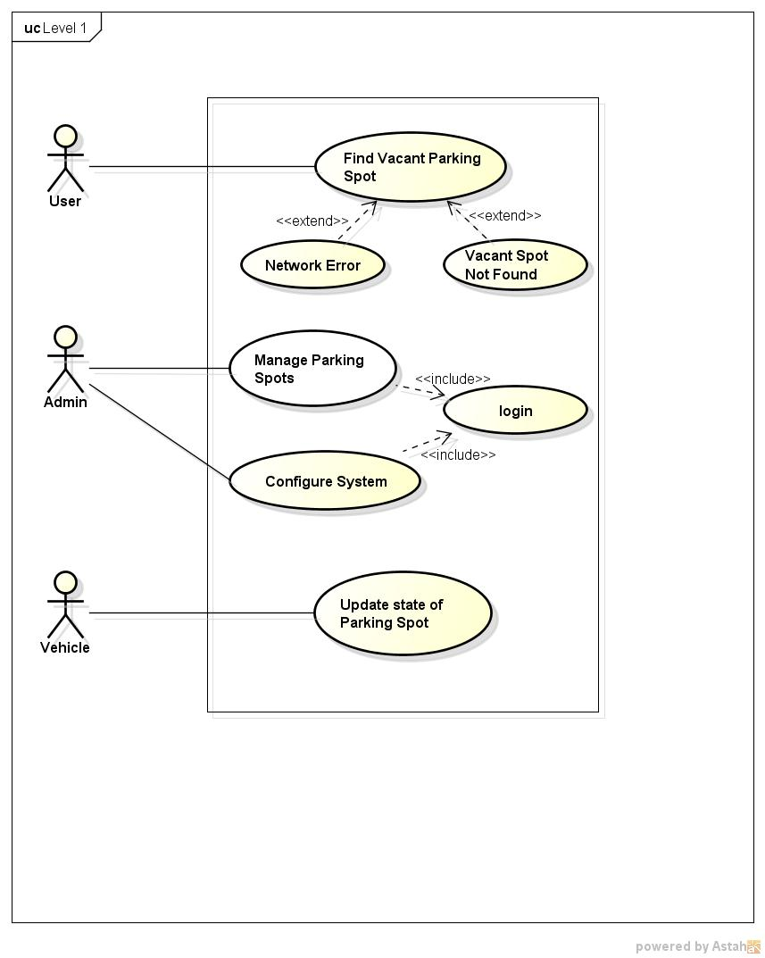

Figure 3 Level 1 Use Case Diagram

# 3. Use Case Specification in Brief Format

**3.1 Level 0 Use Cases**

|  |  |
| --- | --- |
| Use Case 0.1 | |
| ID: UC 0.1 (Level 0) | **Type:** *Base* |
| Name: | Find Vacant Parking Spot |
| Owner: | Arunkumar, Hariprasad, Prasanna Venkatesh, Rekha Muthulakshmi |
| Purpose: | To find a vacant parking spot near the user. The user will specify their preferred color code. The Comet Park system displays the vacant spots in the lot based on the color specified by the user. |
| Pre-conditions: | 1. The CometPark system should have been installed and in running state.  2. The mobile application should have been installed in the user’s mobile phone.  3. The user’s mobile phone must be connected to the internet through Wifi or 4G.  4. The system must maintain the latest snapshot of the parking lots with the updated status. |
| Post-conditions: | 1. The user is able to see the vacant parking spots in the lot based on the color chosen by the user. |
| Reference Documents: | System Requirements Specification Version 3.0 |

|  |  |
| --- | --- |
| Use Case 0.2 | |
| ID: 0.2 UC (Level 0) | **Type:** *Base* |
| Name: | Manage CometPark System |
| Owner: | Arunkumar, Hariprasad, Prasanna Venkatesh, Rekha Muthulakshmi |
| Purpose: | The CometPark system allows the administrator to manage the different aspects of the system from a web interface. This includes managing the configuration of the system, installation of the software and managing the parking spaces by setting some or all the parking lots as closed or open in case of events or emergencies. |
| Pre-conditions: | 1. The CometPark system should have been installed and in running state.  2. The system must have an authorized person as the administrator.  3. The administrator should be familiar with the admin console of the system. |
| Post-conditions: | The administrator will be able to configure the system and set the state of the parking lots as open or closed in case of any issues with the hardware or events happening in the campus. |
| Reference Documents: | System Requirements Specification Version 3.0 |

**3.2 Level 1 Use Cases**

|  |  |
| --- | --- |
| Use Case 1.1 | |
| ID: UC 1.1 (Level 1) | **Type:** *Base* |
| Name: | Find Vacant Parking Spot |
| Owner: | Arunkumar, Hariprasad, Prasanna Venkatesh, Rekha Muthulakshmi |
| Description: | This use case is to help the user find the vacant parking spots in a lot. The user will specify their preferred color code. The Comet Park system displays the vacant spots in the lot based on the color specified by the user. |
| Pre-conditions: | 1. The CometPark system should have been installed and in running state.  2. The mobile application should have been installed in the user’s mobile phone.  3. The user’s mobile phone must be connected to the internet through Wifi or 4G.  4. The system must maintain the latest snapshot of the parking lots with the updated status.  EXTENDS Use Case Network Error (UC 1.2)  EXTENDS Use Case Vacant Spot Not Found (UC 1.3) |
| Post-conditions: | 1. The user is able to see the vacant parking spots in the lot based on the color chosen by the user. |
| Reference Documents: | System Requirements Specification Version 3.0 |

|  |  |
| --- | --- |
| Use Case 1.2 | |
| ID: UC 1.2 (Level 1) | **Type:** *Extends* |
| Name: | Network Error |
| Owner: | Arunkumar, Hariprasad, Prasanna Venkatesh, Rekha Muthulakshmi |
| Description: | If the user’s mobile phone is not able to connect to the internet, the application will show a ‘Network Error’. The user will not be able to see the parking spot information when there is error in the network connection. |
| Pre-conditions: | 1. The CometPark system should have been installed and in running state.  2. The mobile application should have been installed in the user’s mobile phone. |
| Post-conditions: | 1. The application shows a ‘Network Error’ when the user accesses the application without an internet connection. |
| Reference Documents: | System Requirements Specification Version 3.0 |

|  |  |
| --- | --- |
| Use Case 1.3 | |
| ID: 1.3 UC (Level 1) | **Type:** *Extends* |
| Name: | Vacant spot not found |
| Owner: | Arunkumar, Hariprasad, Prasanna Venkatesh, Rekha Muthulakshmi |
| Description: | When all the spots of the preferred color are occupied by vehicles or if all the spaces have been set as closed by the administrator, the user will not be shown any spot. |
| Pre-conditions: | 1. The CometPark system should have been installed and in running state.  2. The mobile application should have been installed in the user’s mobile phone.  3. The user’s mobile phone must be connected to the internet through Wifi or 4G.  4. The system must maintain the latest snapshot of the parking lots with the updated status. |
| Post-conditions: | 1. The user is not shown any parking space as available. |
| Reference Documents: | System Requirements Specification Version 3.0 |

|  |  |
| --- | --- |
| Use Case 1.4 | |
| ID: 1.4 UC (Level 1) | **Type:** *Includes* |
| Name: | Login |
| Owner: | Arunkumar, Hariprasad, Prasanna Venkatesh, Rekha Muthulakshmi |
| Description: | The administrator of the CometPark system must be an authorized user and must be logged in to the system to perform the system management activities. |
| Pre-conditions: | 1. The CometPark system should have been installed and in running state.  2. The system must have a person as the administrator with username and password. |
| Post-conditions: | 1. The administrator is authenticated and logged in to the system. |
| Reference Documents: | System Requirements Specification Version 3.0 |

|  |  |
| --- | --- |
| Use Case 1.5 | |
| ID: 1.5 UC (Level 1) | **Type:** *Base* |
| Name: | Manage Parking lots |
| Owner: | Arunkumar, Hariprasad, Prasanna Venkatesh, Rekha Muthulakshmi |
| Description: | The CometPark system allows the administrator to manage the parking spaces in a lot from a web interface. This includes set some or all the parking lots as closed or open in case of events, maintenance activities or emergency. |
| Pre-conditions: | 1. The CometPark system should have been installed and in running state.  2. The system must have a person assigned as the administrator.  3. The administrator should be familiar with the admin console of the system.  INCLUDES Use Case Login (UC 1.4) |
| Post-conditions: | The administrator will be able to set the desired parking lots as open or closed. |
| Reference Documents: | System Requirements Specification Version 3.0 |

|  |  |
| --- | --- |
| Use Case 1.6 | |
| ID: 1.6 UC (Level 1) | **Type:** *Base* |
| Name: | Configure the system |
| Owner: | Arunkumar, Hariprasad, Prasanna Venkatesh, Rekha Muthulakshmi |
| Description: | The CometPark system allows the administrator to manage the various parameters and configuration of the system such as configuring and managing the cloud service, up gradation and migration. |
| Pre-conditions: | 1. The CometPark system should have been installed and in running state.  2. The system must have a person assigned as the administrator.  3. The administrator should be familiar with the admin console of the system.  INCLUDES Use Case Login (UC 1.4) |
| Post-conditions: | The administrator will be able to configure and manage the system |
| Reference Documents: | System Requirements Specification Version 3.0 |

|  |  |
| --- | --- |
| Use Case 1.7 | |
| ID: UC 1.7 (Level 1) | **Type:** *Base* |
| Name: | Update State of Parking Spot |
| Owner: | Arunkumar, Hariprasad, Prasanna Venkatesh, Rekha Muthulakshmi |
| Description: | When a vehicle arrives at a parking spot, the state of the parking spot is updated as ‘Occupied’. When a vehicle leaves the parking spot, the state is updated as ‘Available’. |
| Pre-conditions: | 1. The CometPark system should have been installed and in running state. |
| Post-conditions: | 1. The state of the parking spot is updated when a vehicle arrives or leaves. |
| Reference Documents: | System Requirements Specification Version 3.0 |

# 4. Use Case Prioritization

|  |  |  |
| --- | --- | --- |
| PRIORITY | USE CASE ID | USE CASE NAME |
| 1 | 1.7 | Update State of Parking Spot |
| 2 | 1.1 | Find Vacant Parking Spot |
| 3 | 1.4 | Login |
| 4 | 1.5 | Manage Parking Spots |
| 5 | 1.6 | Configure the system |
| 6 | 1.3 | Vacant Spot not found |
| 7 | 1.2 | Network Error |

# 5. Use Case Specification in Fully Dressed Format

|  |  |
| --- | --- |
| Use Case 1.7 Update State of Parking Spot | |
| ID: UC 1.7 | Type: **Base** |
| Brief Description | When a vehicle arrives at a parking spot, the state of the parking spot is updated as ‘Occupied’. When a vehicle leaves the parking spot, the state is updated as ‘Available’. |
| Primary Actors | Vehicle |
| Secondary Actors |  |
| Preconditions | 1. The CometPark system should have been installed and in running state. |
| Main Flow: | 1. The sensor gets the information as to how far an object is sensed 2. If the object is within certain range, the spot is considered to be currently used for parking/ 3. This status is updated to the Controller 4. The Controller persists the data to the Cloud Database |
| Postconditions: | 1. The state of the parking spot is updated when a vehicle arrives or leaves. |
| Alternative Flows: | None |

|  |  |
| --- | --- |
| Use Case 1.1 Find Vacant Parking Spot | |
| ID: UC 1.1 | Type: **Base** |
| Brief Description | This use case is to help the user find the vacant parking spots in a lot. The user will specify their preferred color code. The Comet Park system displays the vacant spots in the lot based on the color specified by the user. |
| Primary Actors | User |
| Secondary Actors | Vehicle |
| Preconditions | 1. The CometPark system should have been installed and in running state.  2. The mobile application should have been installed in the user’s mobile phone.  3. The user’s mobile phone must be connected to the internet through Wifi or 4G.  4. The system must maintain the latest snapshot of the parking lots with the updated status. |
| Main Flow: | 1. The AppUser clicks on Find Parking Space button 2. The AppUser is prompted for the Color Code of the Parking Spot   extension point: Wifi and 4G is off, Extension: Network Error (UC 1.2)   1. The status as to the availability of Parking Space, is returned to the user.   extension point: parkingLotFull, Extension: Vacant Spot Not Found (UC 1.3). |
| Postconditions: | 1. The user is able to see the vacant parking spots in the lot based on the color chosen by the user. |
| Alternative Flows: | Wifi and 4G is off  parkingLotFull |

|  |  |
| --- | --- |
| Use Case 1.4 Login | |
| ID: UC 1.4 | Type: **Include** |
| Brief Description: | The administrator of the CometPark system must be an authorized user and must be logged in to the system to perform the system management activities. |
| Primary Actors: | Admin |
| Secondary Actors | None |
| Preconditions: | 1. The CometPark system should have been installed and in running state.  2. The system must have a person as the administrator with username and password. |
| Main Flow: | 1. The administrator must use the URL to access the CometPark admin console 2. The administrator must give the correct login credentials to enter to the admin page 3. If the login credentials is wrong, then an error is displayed and the login page is displayed for reentering the credentials. |
| Postconditions: | 1. The administrator is authenticated and logged in to the system. |
| Alternative Flows: | None |

|  |  |
| --- | --- |
| Use Case 1.5 Manage Parking Spot | |
| ID: UC 1.5 | Type: **Base** |
| Brief Description | The CometPark system allows the administrator to manage the parking spaces in a lot from a web interface. This includes set some or all the parking lots as closed or open in case of events, maintenance activities or emergency. |
| Primary Actors | Admin |
| Secondary Actors |  |
| Preconditions | 1. The CometPark system should have been installed and in running state.  2. The system must have a person assigned as the administrator.  3. The administrator should be familiar with the admin console of the system. |
| Main Flow: | 1. include(Login ) 2. The system shall prompt the user to choose Manage Parking Space or Configure the System. 3. Choose Manage Parking Space option. 4. The system displays the Manage Parking Space page 5. The administrator updates the Parking Spot status as Opened or Closed and click on the save button. 6. An acknowledgement is sent for any successful updates to the system. |
| Postconditions: | The administrator will be able to set the desired parking lots as open or closed. |
| Alternative Flows: | Any unsuccessful updates will receive an Error Message |

|  |  |
| --- | --- |
| Use Case 1.6 Configure the System | |
| ID: UC 1.6 | Type: **Base** |
| Brief Description | The CometPark system allows the administrator to manage the various parameters and configuration of the system such as configuring and managing the cloud service, up gradation and migration. |
| Primary Actors | Admin |
| Secondary Actors | None |
| Preconditions | 1. The CometPark system should have been installed and in running state.  2. The system must have a person assigned as the administrator.  3. The administrator should be familiar with the admin console of the system. |
| Main Flow: | 1. include(Login ) 2. The system shall prompt the user to choose Manage Parking Space or Configure the System. 3. Choose Configure the System option. 4. The system displays the Configure the System page 5. The Admin shall make any changes to the system using the options availab;e and shall click on ok. 6. The configuration is saved. |
| Postconditions: | The new setting will be applied to the entire system. |
| Alternative Flows: | None |

|  |  |
| --- | --- |
| Use Case 1.3 Vacant Spot Not Found | |
| ID: UC 1.3 | Type: **Extends** |
| Brief Description: | When all the spots of the preferred color are occupied by vehicles or if all the spaces have been set as closed by the administrator, the user will not be shown any spot. |
| Primary Actors: | User |
| Secondary Actors: | Vehicle |
| Segment 1 |  |
| Preconditions: | 1. The CometPark system should have been installed and in running state.  2. The mobile application should have been installed in the user’s mobile phone.  3. The user’s mobile phone must be connected to the internet through Wifi or 4G.  4. The system must maintain the latest snapshot of the parking lots with the updated status.  5. The system has no Parking Spots available |
| Main Flow:  1.  2. | 1. The system returns the Error Message to be displayed on the screen for the user. |
| Postconditions: | 1. The user is not shown any parking space as available. |
| Open Issues: | None |

|  |  |
| --- | --- |
| Use Case 1.2 Network Error | |
| ID: UC 1.2 | Type: **Extends** |
| Brief Description: | If the user’s mobile phone is not able to connect to the internet, the application will show a ‘Network Error’. The user will not be able to see the parking spot information when there is error in the network connection. |
| Primary Actors: | User |
| Secondary Actors: | None |
| Segment 1 |  |
| Preconditions: | 1. The CometPark system should have been installed and in running state.  2. The mobile application should have been installed in the user’s mobile phone.  3. The request did not respond with a 200 OK |
| Main Flow: | 1. An error message is displayed on the web page |
| Postconditions: | 1. The application shows a ‘Network Error’ when the user accesses the application without an internet connection. |
| Open Issues: | None |

# 6. Black Box Sequence Diagrams

6.1 UC 1.7 Update state of Parking Spot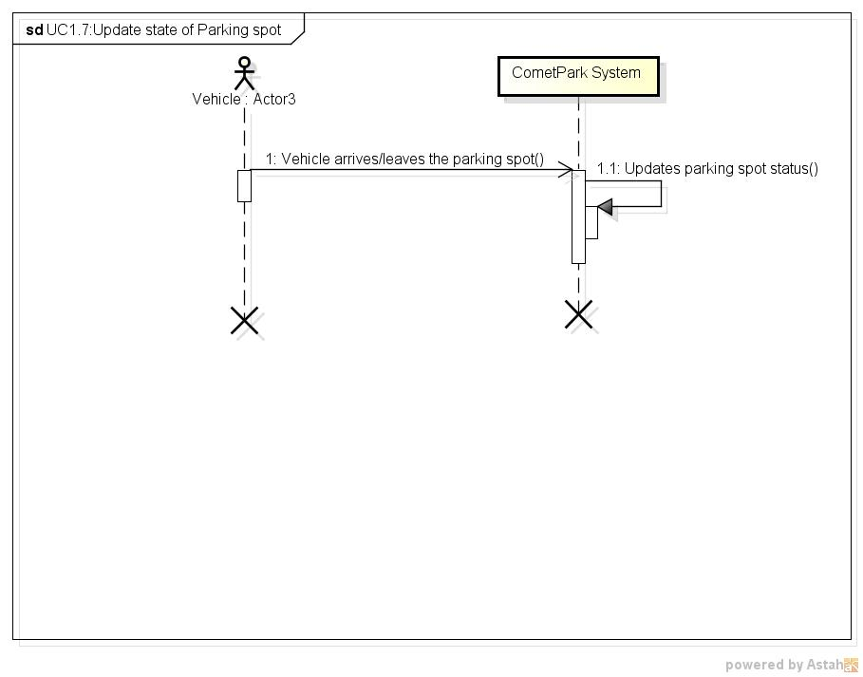

Figure 4 Update State of Parking Spot BB-SD

## 6.2 UC 1.1 Find Vacant Parking Spot

## C:\REKHA\cometpark\Documents\BBSD\New Diagrams\UC1.1_Find Vacant Parking Spot.jpg

Figure 5 Find Vacant Parking Spot BB-SD

6.3 UC 1.4 Login**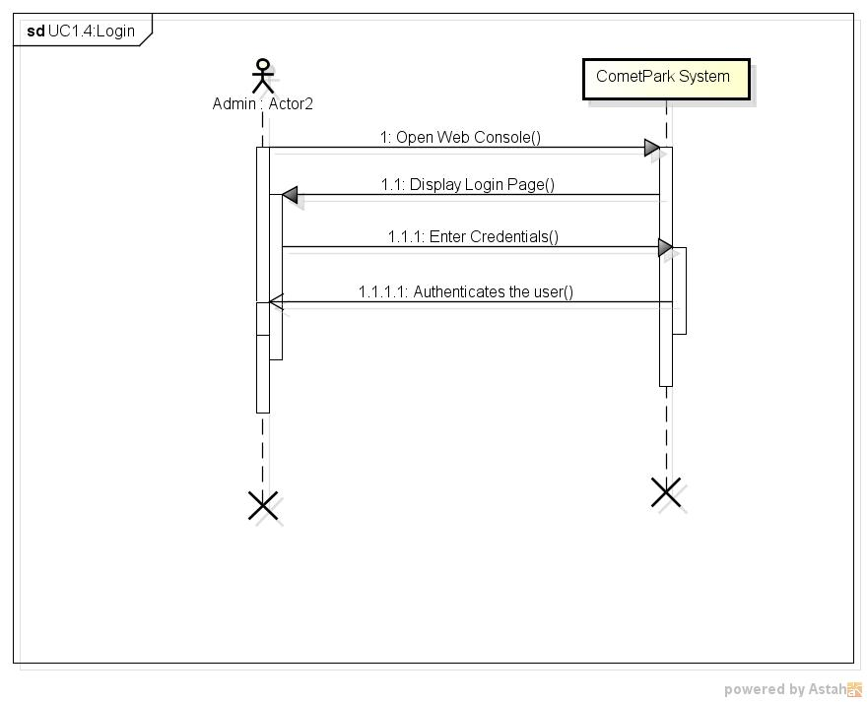**

Figure 6 Login BB-SD

## 6.4 UC 1.5 Manage Parking Spots

**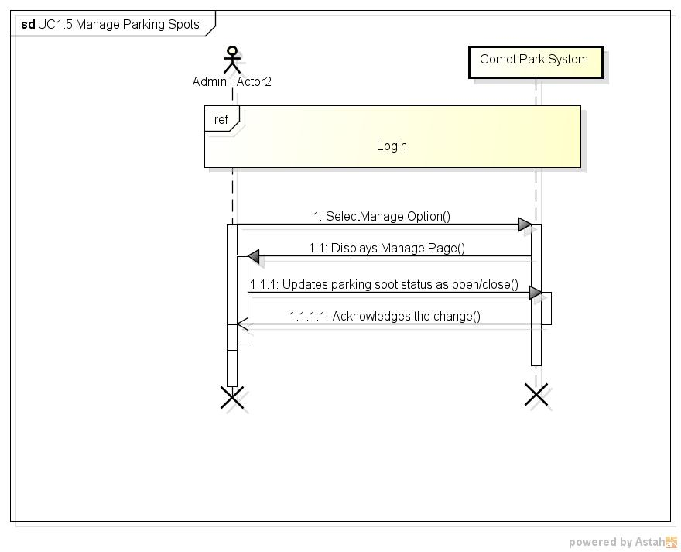**

Figure 7 Manage Parking Spots BB-SD

## 6.5 UC 1.6 Configure System

**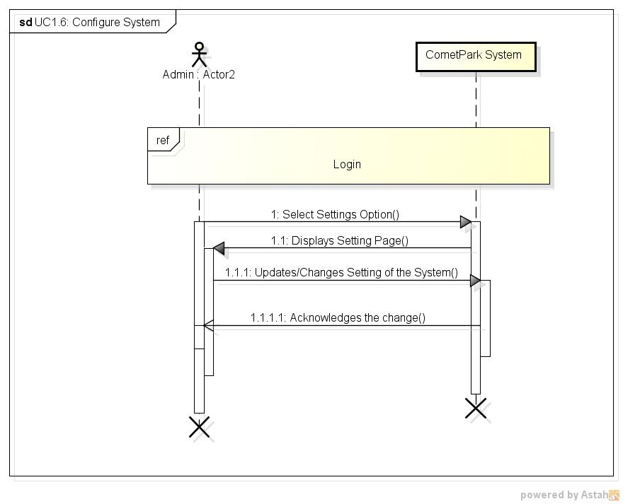**

Figure 8 Configure System BB-SD

# 7. Traceability Matrix

# 

Figure 9 Traceability Matrix

# Appendix A: Glossary

|  |  |
| --- | --- |
| **Term** | **Definition** |
| Wifi | Technology that allows devices to connect to the internet wirelessly using radio waves |
| UCD | Use case diagram. It is a representation of the users’ interaction with the system. |
| 3G | Third generation of Mobile Telecommunication technology for information transfer. Transfer rate is at least 200kbits/sec. |
| 4G | Fourth generation of mobile technology with mobile broadband capabilities. |